**Task 4: Creating a Prototype User Interface & Usability Testing**

**Prototype User Interface**

Login Page & Registration Page

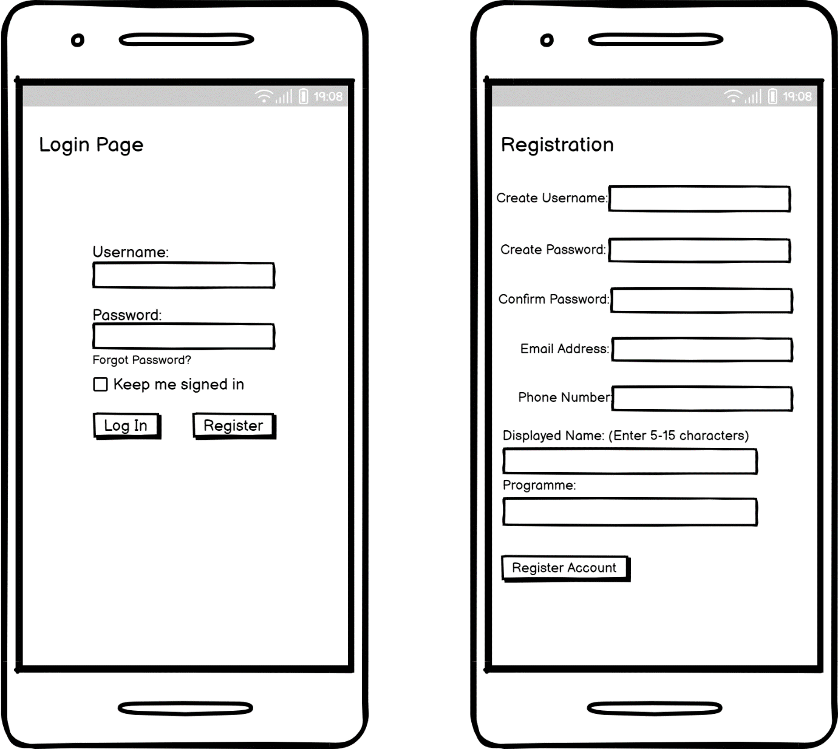

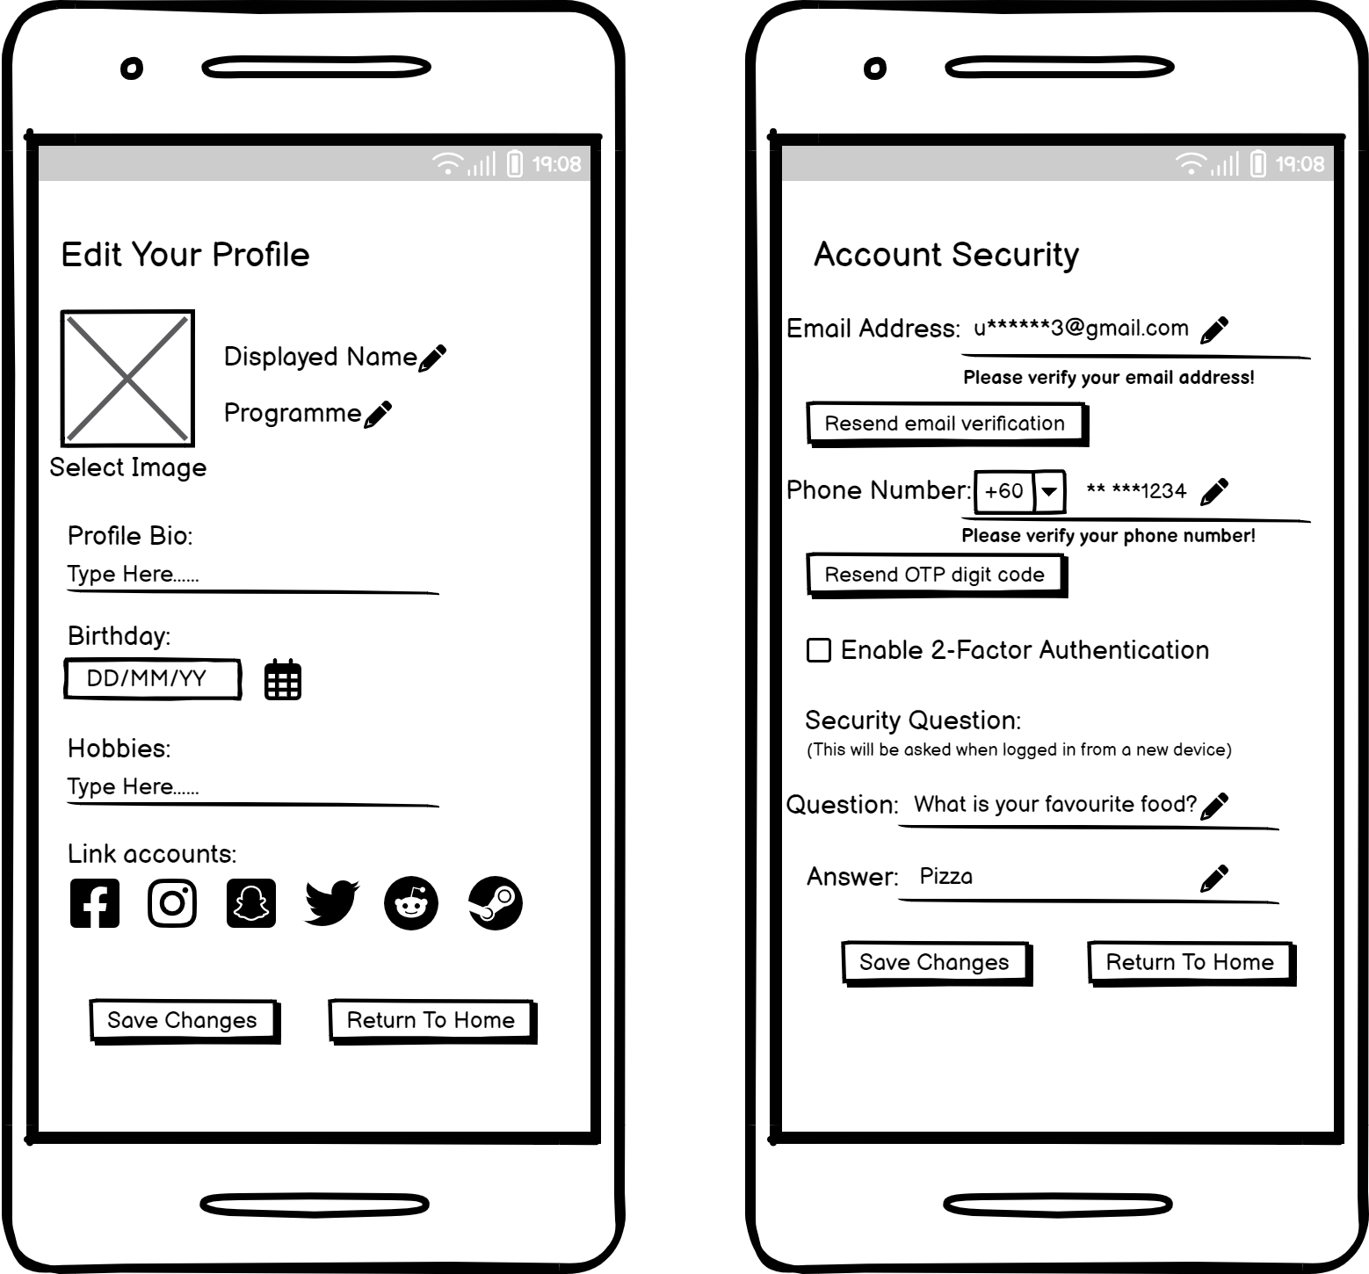Profile Setup & 2-Step Verification

When the user successfully logs into the college buddy system for the first time, a pop-up window will appear to let users sign the agreement of the terms and conditions apply to use the college buddy system. After that, the users will be brought to the profile setup page to let them setup their profile properly. The users could pick an image as the user’s profile picture, type out a bio to give a brief introduction about the user, select their date of birth by clicking the calendar icon and type out the user’s hobbies so that other users could find someone with some common ground to begin with. After that, the user can link existing accounts from other platforms in case the user wants to share their social media to other users.

After setting up the user’s profile, a verification window will pop up to notify the user about enforcing the account’s security. The users can setup these extra security measures at another time but it is not recommended. But if the user chooses to setup at this instance, the system will require the user to verify both the user’s email address and phone number. The user can also setup a security question to further enforce their account, the system will only ask the security question if the user logs in from a new device. Some users might want to take their security to a whole new level and that’s where the 2-factor authentication comes into play. If the user decides to enable this feature, the system will request the user to enter a 6-digit code every time they log into the system. The users can access the 6-digit code through any authenticator app from the Play Store or the App Store.

Homepage

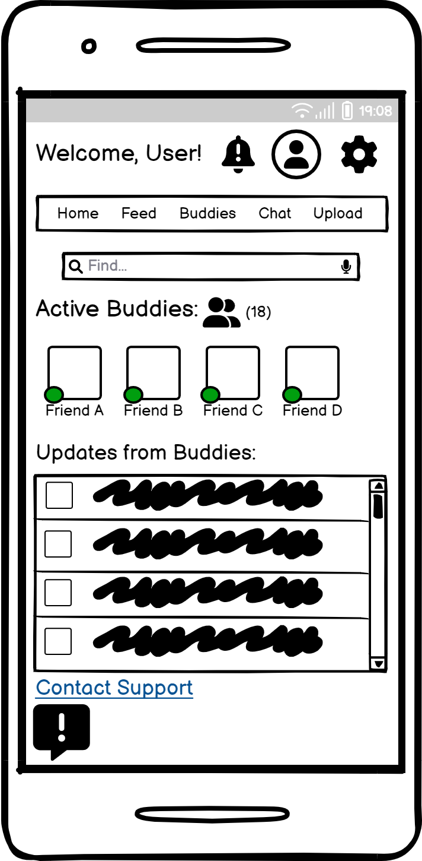

Moving on, the user will arrive at this designated homepage of the college buddy system. Starting from the top of the screen, the user can click on the bell icon to check if the user has received any notifications, the icon next to it is the profile icon where the user can edit their profile as the user sees fit. Then, there is a cog icon which is the settings of the college buddy system, the settings page will be displayed on the next page.

There is a menu bar below the 3 icon which brings the user to each of their respective page when clicked, the home button in the menu bar will refresh the homepage when click. Then, there is the “Active Buddies” section where the users can view which of their buddies are online at the moment. Last but not least, there is a catalogue which will notify the user of updates made by the user’s buddies. If the user encountered a bug or a problem with the college buddy system, the user could contact support from administrators for assistance

Settings

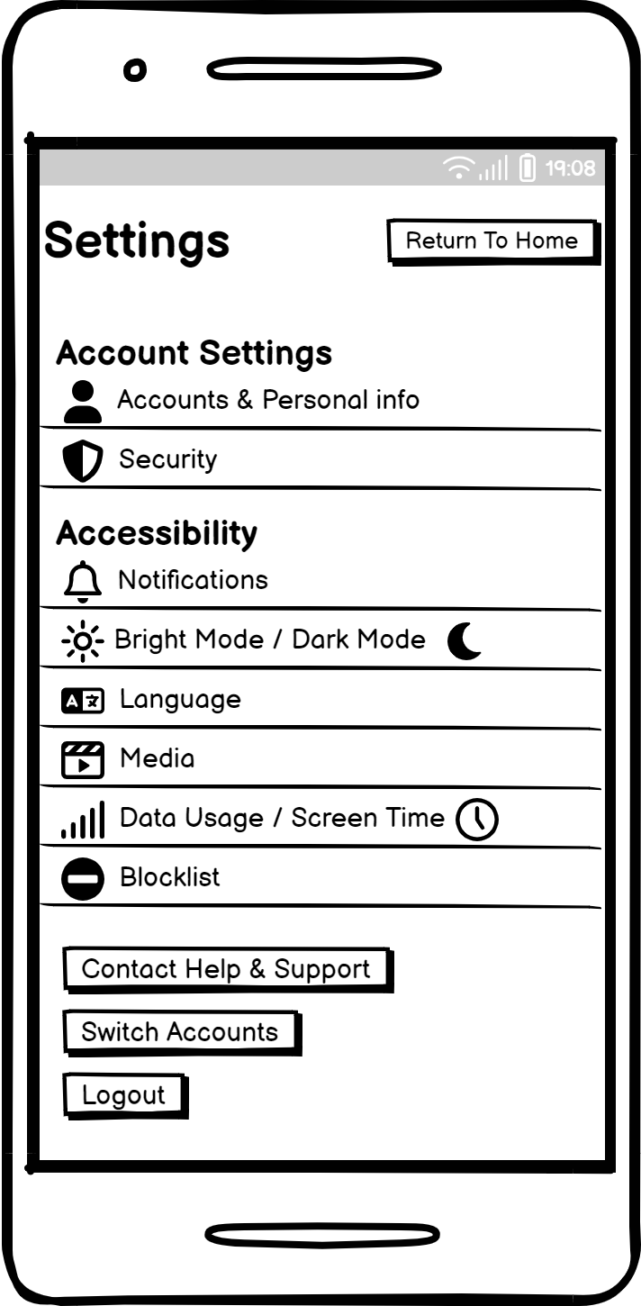

Search Section & Viewing Other User’s Profile

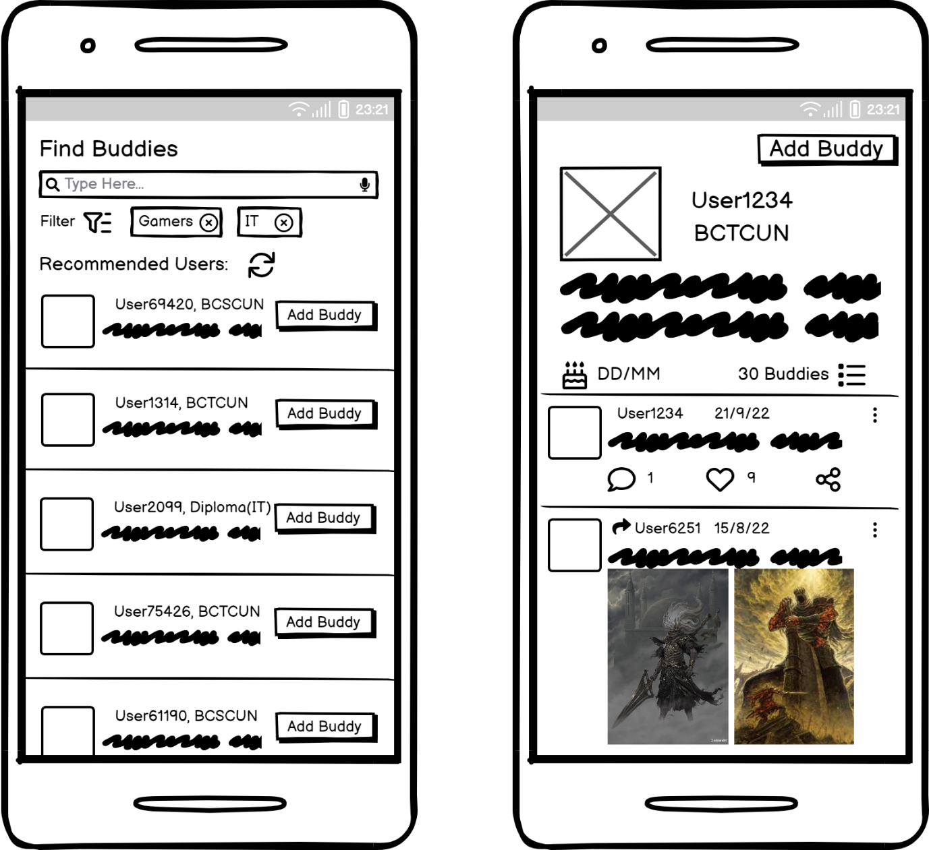

Feed

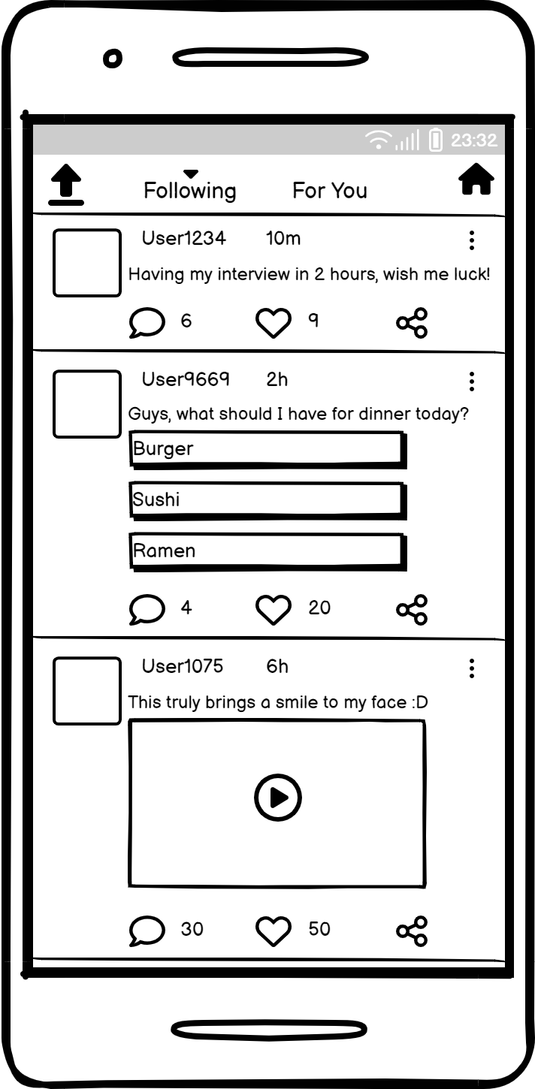

Chat Section & Upload Section

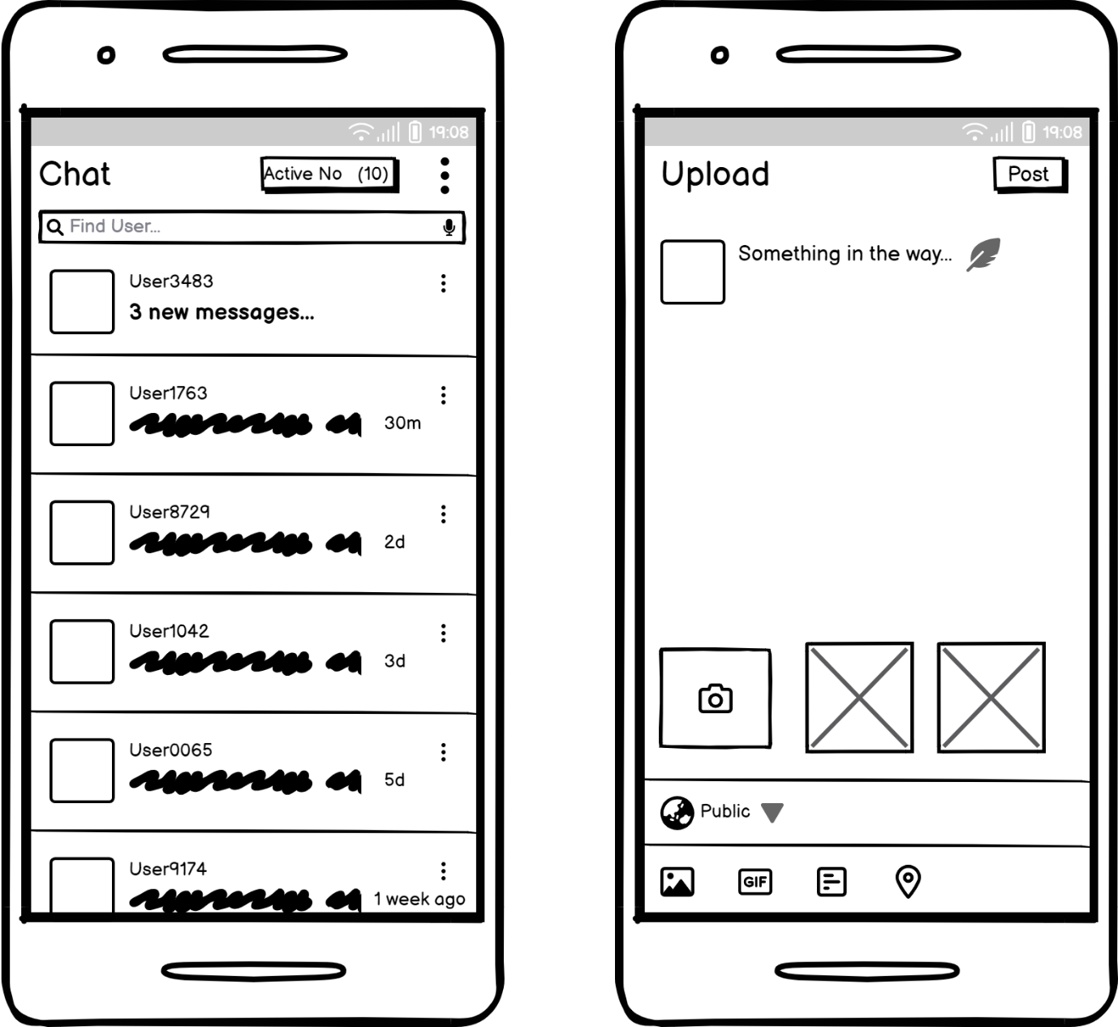

For the grand finale, these 2 pages will be used the most by the users in order to communicate with the users’ buddies which is the chat section and the upload section of the college buddy system. Starting with the chat section, the users can directly interact with the buddies the users made along the way by sending them messages or even share videos and images. This feature was the most requested feature based on the data collected from the users’ responses. Along side the chat section, we have the upload section where the users can write the user’s thoughts or post something to share with their buddies. The user can decide to share the post towards the public which means that all users of the college buddy system will be able to see in the user’s feed or just share among the user’s respective buddies. The 4 icons at the icon are the gallery icon, gif icon, poll icon and the share location icon.

**Usability Testing Questions**

This usability testing strives to collect responses from the users after that the users have taken their time to observe and interact with the college buddy system for a period of time. It is also crucial to know how the users feel about the college buddy system and how well does this system implement into the user’s college social life.

For each of the questions below, the users will respond by circling the number that could best describe how the users feel about the college buddy system.

1 - Strongly Disagree 2 - Disagree 3 - Neutral 4 - Agree 5 - Strongly Agree

|  |  |  |  |  |  |
| --- | --- | --- | --- | --- | --- |
|  | Strongly Disagree | Disagree | Neutral | Agree | Strongly Agree |
| 1. I am satisfied with the app at its current state. | 1 | 2 | 3 | 4 | 5 |
| 1. The app runs smoothly on my phone. | 1 | 2 | 3 | 4 | 5 |
| 1. I encountered no bugs or technical issues while using the app. | 1 | 2 | 3 | 4 | 5 |
| 1. This app has assisted me in improving my college social life. | 1 | 2 | 3 | 4 | 5 |
| 1. I would recommend this app to a friend. | 1 | 2 | 3 | 4 | 5 |
| 1. This app is user-friendly and easy to familiarise with. | 1 | 2 | 3 | 4 | 5 |
| 1. Do you think this app has managed to fulfil its purpose? | 1 | 2 | 3 | 4 | 5 |
| 1. Is the user interface well designed? | 1 | 2 | 3 | 4 | 5 |
| 1. Are the settings available to the user sufficient? | 1 | 2 | 3 | 4 | 5 |
| 1. Does this app needs more features to reach the expectations of a good app? | 1 | 2 | 3 | 4 | 5 |